Applied Microeconomics — Lecture 2: Externalities
The Pharma example, one area of the graph at a time
Built from Lecture 2 - Externalities.pptx (Delfgaauw, slides 9–31) and Rosen & Gayer ch. 5. The lecture graph has no numbers; the figures here are drawn with MPB = 10 − Q, MPC = Q and MD = ½Q so every area can be checked. Shapes and letter positions match the slides.

The setup
- Who pollutes: Pharma, a fictitious chemicals firm, discharges waste into the Rhine as a by-product of production.
- Who is harmed: tomato growers in the Westland irrigate their greenhouses with Rhine water. The pollution stunts the tomatoes.
- Why it's a market failure: nobody owns the river, so there is no price for dumping in it. To Pharma, pollution is free — the damage never appears on its bill.

Step by step

Step 1 — The four curves slides 9–10
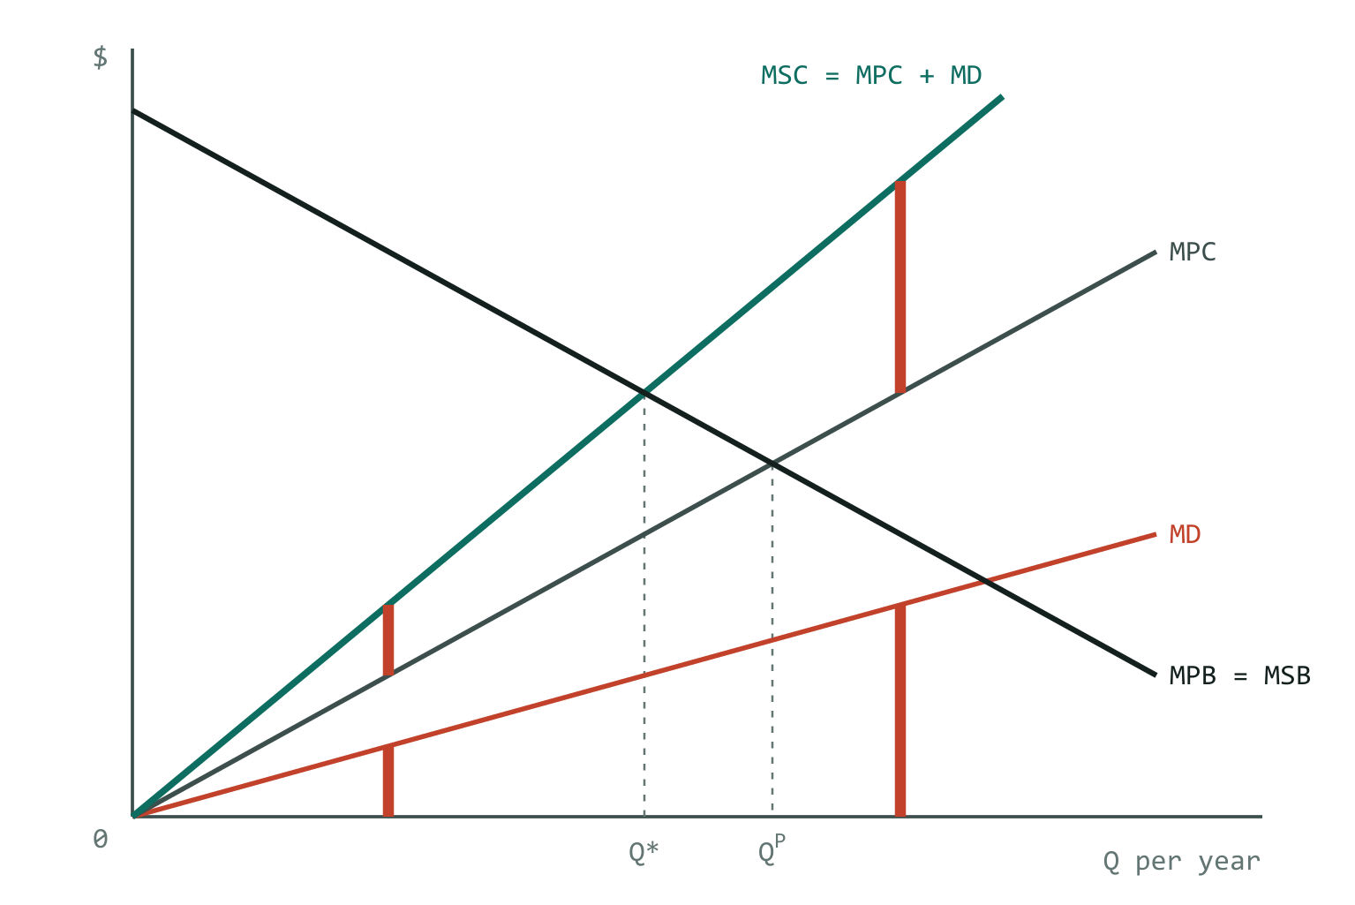
The red bars: the gap between MPC and MSC equals the height of MD, at every Q.
MPB — marginal private benefit: what Pharma gets from producing one more unit. It slopes down.
MPC — marginal private cost: what one more unit costs Pharma in inputs and labour. It rises.
MD — marginal damage: the extra harm the growers suffer from one more unit. It rises, because more pollution hurts at an increasing rate.
MSC — marginal social cost: what one more unit costs society, i.e. Pharma's cost plus the growers' damage. You build it by stacking MD on top of MPC.
MSC = MPC + MD so the gap between MSC and MPC is exactly MD, at every Q
In numbers: MSC = Q + ½Q = 1.5Q. At Q = 2 the gap is 3 − 2 = 1 = MD(2). At Q = 6 it is 9 − 6 = 3 = MD(6).

Step 2 — What Pharma does: Q^{P} slide 11
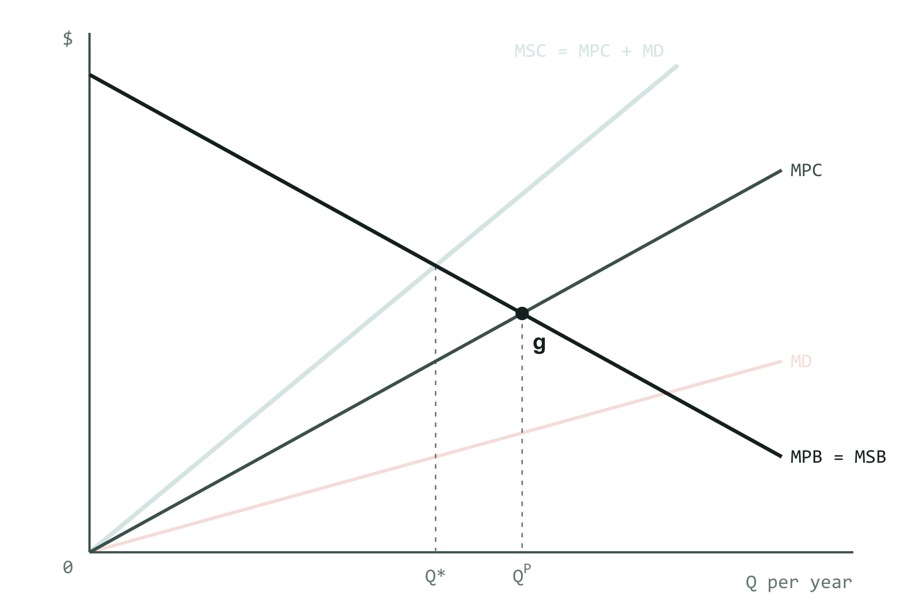
Pharma looks only at MPB and MPC. It produces up to point g.
Pharma only counts its own benefit and cost. While MPB > MPC, one more unit adds to profit, so it keeps producing. It stops where the two curves cross — point g.
MPB = MPC → Q = Q^{P} the market outcome
The growers want the opposite extreme: every unit damages them, so they would like Q = 0. Neither extreme is efficient, because each side ignores the other.
In numbers: 10 − Q = Q → Q^{P} = 5.

Step 3 — What society wants: Q* slides 11, 15
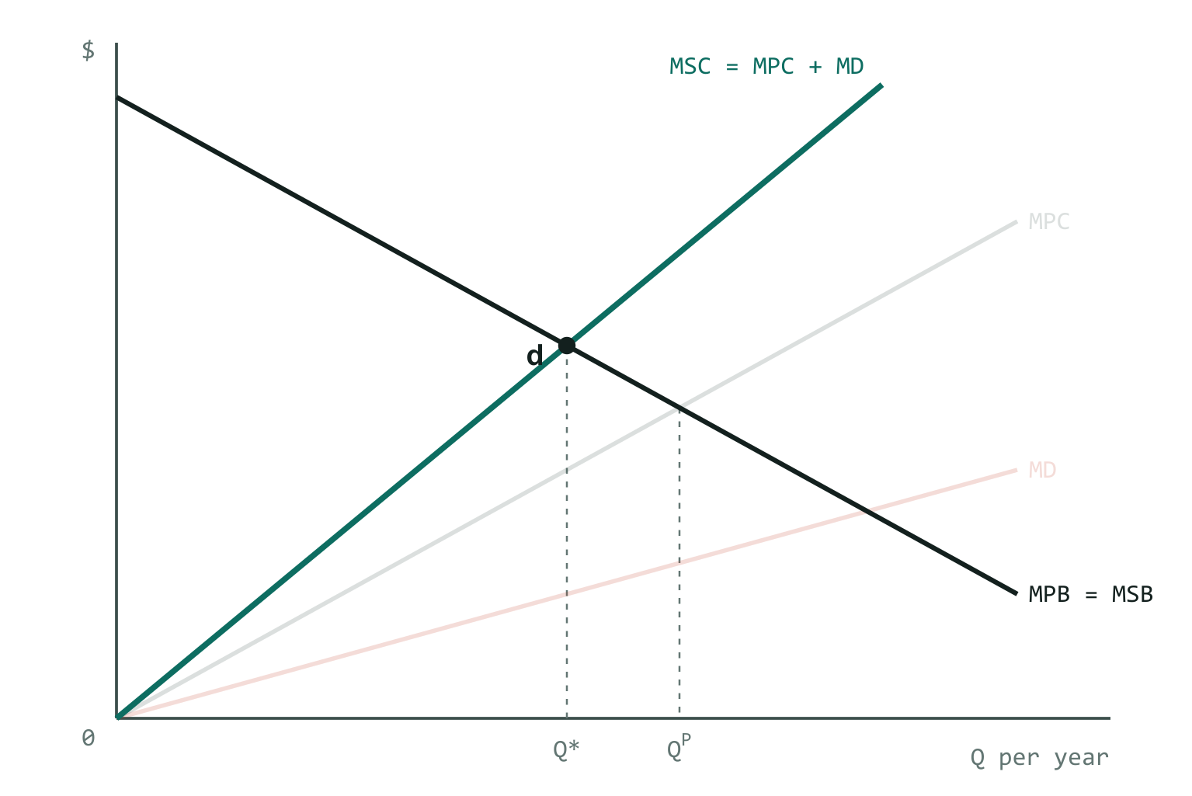
Society compares MSB with MSC. They cross at point d.
The efficiency rule is always marginal social benefit = marginal social cost. Fill in each side for this example:
MSB = MSC
MSB = MPB nobody else benefits from the chemicals
MSC = MPC + MD the damage is a cost to society
→ MPB = MPC + MD → Q = Q*
That is point d, where MPB meets MSC. Because MSC lies above MPC, it crosses MPB earlier: **Q* < Q^{P}**. A negative externality means overproduction.
Slide 11's warning: these are marginal costs and benefits — the value of the last unit — not totals.
In numbers: 10 − Q = 1.5Q → Q* = 4. Pharma overproduces by one unit.

Step 4 — Cutting to Q*: what Pharma loses, area dcg slides 13–14
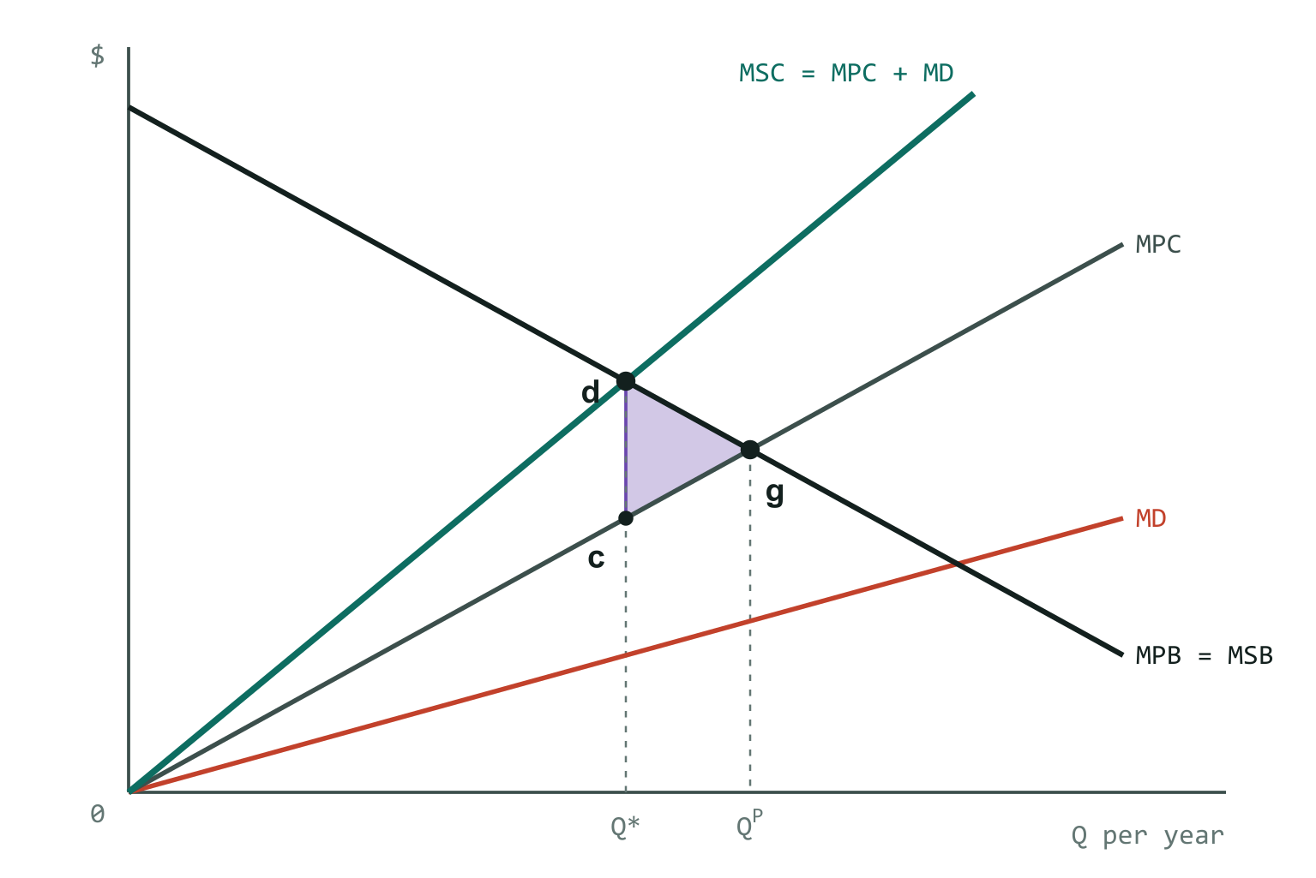
Area dcg (purple): Pharma's lost profit.
Take each unit between Q* and Q^{P}. On that unit Pharma was earning MPB − MPC — the vertical distance between those two curves. Add up those slivers from Q* to Q^{P} and you get the triangle dcg. That is Pharma's lost profit.
Why a triangle? At Q^{P} (point g) the last unit earns zero extra profit because the curves meet. Moving back towards Q*, profit per unit grows until it equals the distance cd.
lost profit = area dcg = ∫ from Q* to Q^{P} of (MPB − MPC) dQ
dcg and cdg are the same triangle — slide 20 simply writes the letters in a different order. It is Pharma's LOST profit from the cut, not Pharma's total profit. Pharma's total profit at Q^{P} is the whole region between MPB and MPC from 0 to g.
In numbers: ½ × base (5 − 4) × height (6 − 4) = 1.

Step 5 — What the growers gain, area abfe slide 13
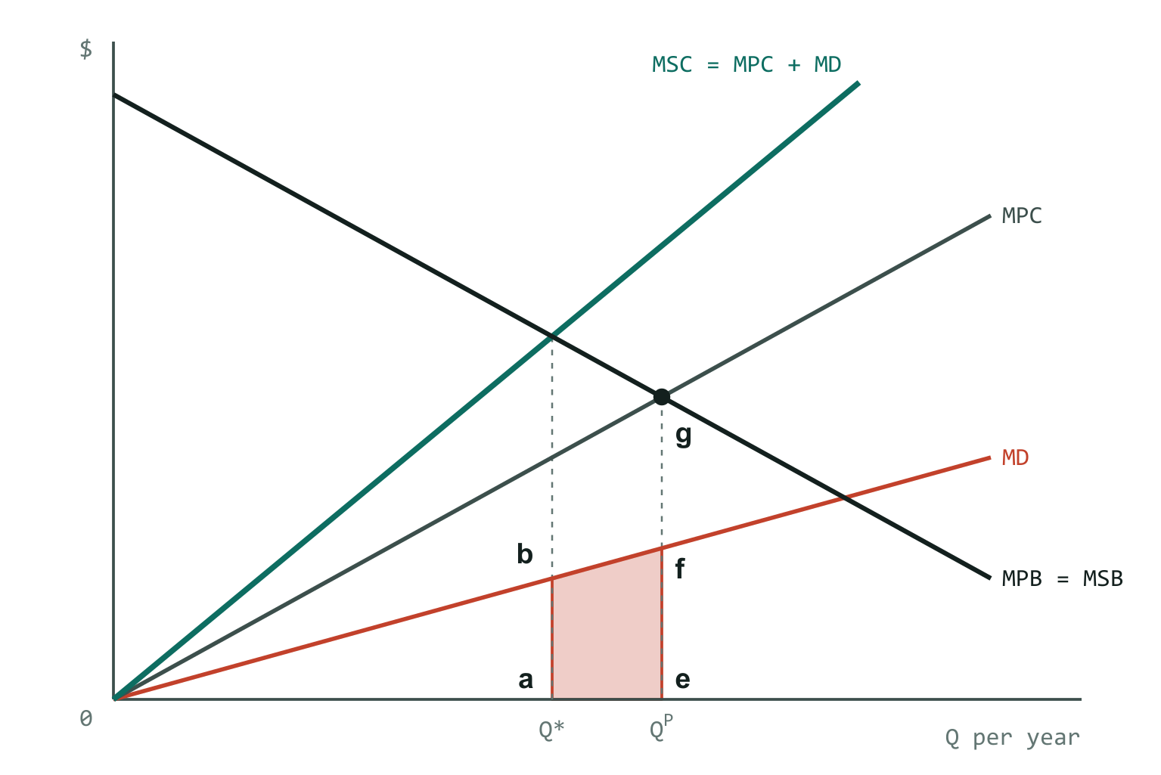
Area abfe (red): the area under MD between Q* and Q^{P}.
Every unit Pharma stops producing removes MD of damage. Add up the MD of every unit between Q* and Q^{P} and you get the area under the MD curve between them: abfe.
a and e sit on the axis at Q* and Q^{P}; b and f sit on the MD curve directly above them.
growers' gain = area abfe = ∫ from Q* to Q^{P} of MD dQ
In numbers: ∫ ½Q from 4 to 5 = (25 − 16)/4 = 2.25.

Step 6 — The key trick: abfe = cdhg slide 13
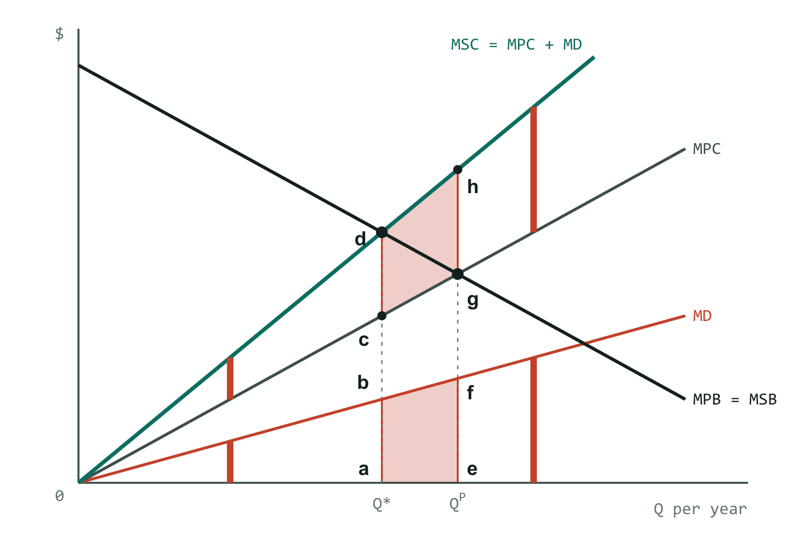
Both red areas are the same size, because the MSC–MPC gap equals MD everywhere.
The growers' gain sits at the bottom of the graph and Pharma's loss sits at the top. To compare them you need them in the same place.
Step 1 showed that the gap between MSC and MPC is MD at every quantity. So the band between MPC and MSC from Q* to Q^{P} — area cdhg — has exactly the same height as abfe at every Q, and therefore exactly the same area.
area abfe = area cdhg same heights, same width
Now the growers' gain (cdhg) sits right next to Pharma's loss (dcg), and you can see that dcg fits inside cdhg.
In numbers: ∫ (1.5Q − Q) from 4 to 5 = ∫ ½Q = 2.25 — identical to step 5.

Step 7 — The deadweight loss, area dhg slides 13, 15
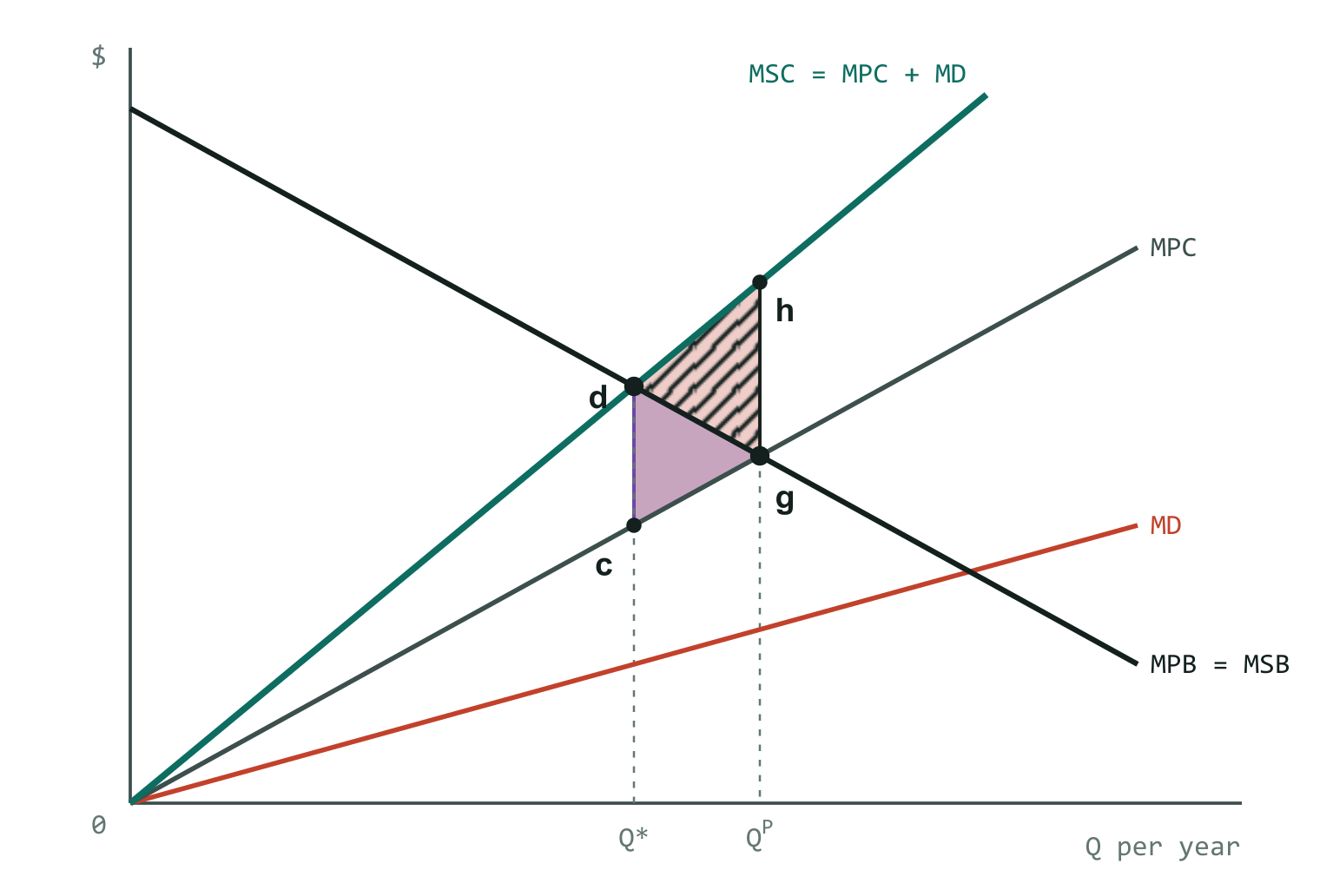
Red band cdhg = growers' gain. Purple dcg = Pharma's loss. Hatched dhg = what is left over.
Growers gain cdhg; Pharma loses dcg; dcg is the lower part of cdhg. What is left over is the triangle dhg:
net gain from moving Q^{P} → Q* = cdhg − dcg = area dhg
= ∫ from Q* to Q^{P} of (MSC − MSB) dQ slide 15
The unit-by-unit reason: for every Q beyond Q*, MD > MPB − MPC. The damage a unit does to the growers is bigger than the profit it earns Pharma. So each unit cut, all the way back to Q*, helps the growers more than it hurts Pharma. Cut past Q* and it reverses.
dhg is not anybody's profit. It is the deadweight loss of producing at Q^{P} — the net amount society loses — and equally the efficiency gain from moving to Q*.
In numbers: 2.25 − 1 = 1.25. Check: ∫ (1.5Q − (10 − Q)) from 4 to 5 = ∫ (2.5Q − 10) = 1.25.

Step 8 — Coase: if Pharma owns the river slides 18–21
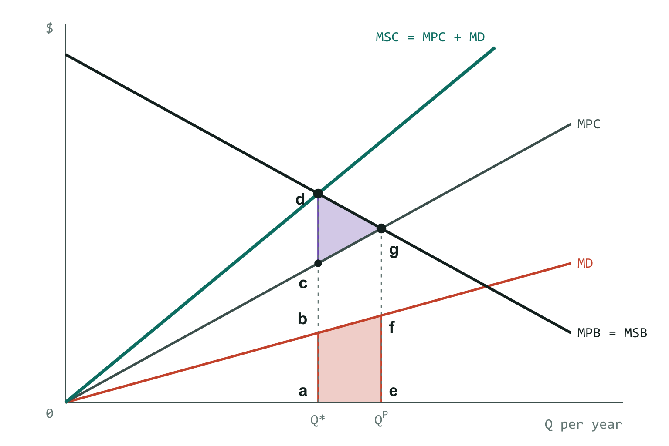
Purple dcg = minimum payment. Red abfe = maximum payment. Growers pay Pharma.
Pharma is allowed to pollute, so the starting point is Q^{P}. But step 7 showed a cut is worth more to the growers than it costs Pharma, so there is a deal to be made: the growers pay Pharma to produce less.
growers will pay at most: MD per unit cut
Pharma accepts at least: MPB − MPC per unit cut
deals continue while: MD > MPB − MPC
stop where: MD = MPB − MPC → MPB = MPC + MD → Q*
Bargaining lands on exactly the efficient output, with no government involved. The total payment from growers to Pharma lies between:
- Minimum: dcg — anything less and Pharma is worse off than simply producing Q^{P}.
- Maximum: abfe — anything more and the growers would rather put up with the pollution.
Where in that range they settle depends on bargaining power. The gap between the two, dhg, is the surplus they split.
This requires the Coase conditions (slides 18, 24): property rights established and enforced, and low transaction costs — few parties, easy to agree and enforce, no asymmetric information. Thousands of growers negotiating with Pharma would fail.
In numbers: transfer between 1 and 2.25.

Step 9 — Coase: if the growers own the river slides 22–23
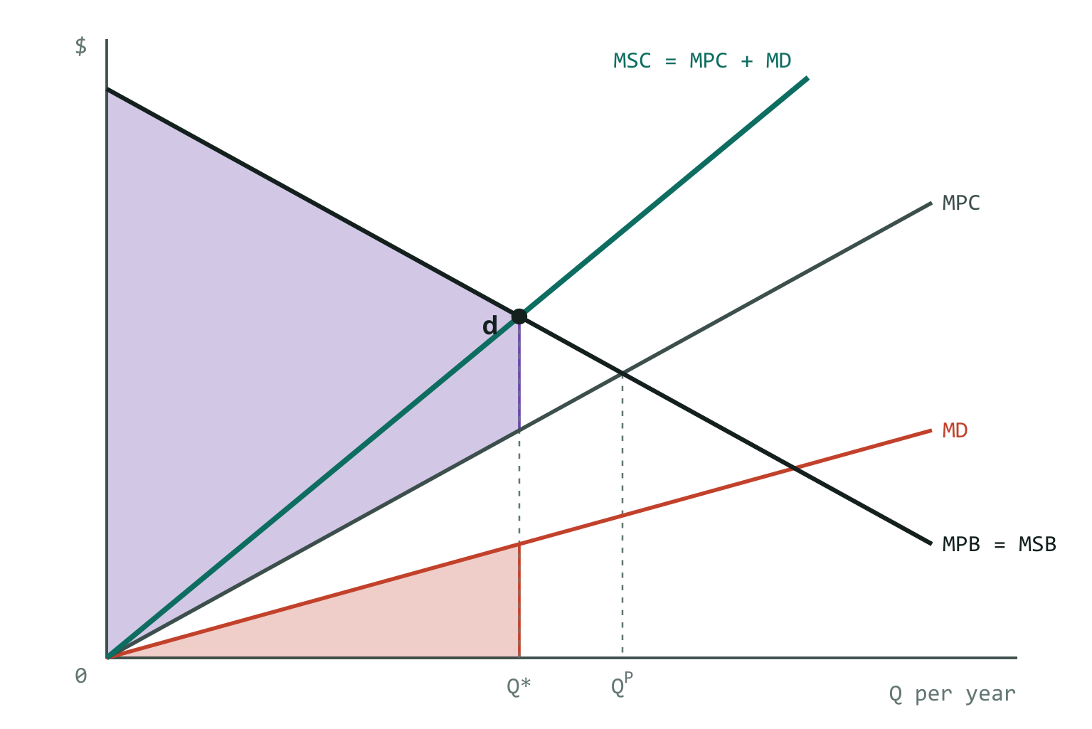
Red = damage at Q* (minimum payment). Purple = Pharma's profit at Q* (maximum payment). Pharma pays growers.
Now Pharma needs permission to pollute, so the starting point is Q = 0. Pharma pays the growers for the right to produce.
Pharma will pay at most: MPB − MPC per unit allowed
growers accept at least: MD per unit allowed
expand while: MPB − MPC > MD → same stopping point: Q*
The payment from Pharma to the growers lies between:
- Minimum: the damage at Q* — the area under MD from 0 to Q*. Less than that and the growers won't allow it.
- Maximum: Pharma's profit at Q* — the area between MPB and MPC from 0 to Q*. More than that and Pharma would rather shut down.
Compare with step 8: **same Q*, money flows the other way.** Who owns the river changes the distribution, not the efficiency (slide 18).
In numbers: damage ∫ ½Q from 0 to 4 = 4; Pharma's profit ∫ (10 − 2Q) from 0 to 4 = 24. Transfer between 4 and 24.

Step 10 — Pigouvian tax slides 26–28
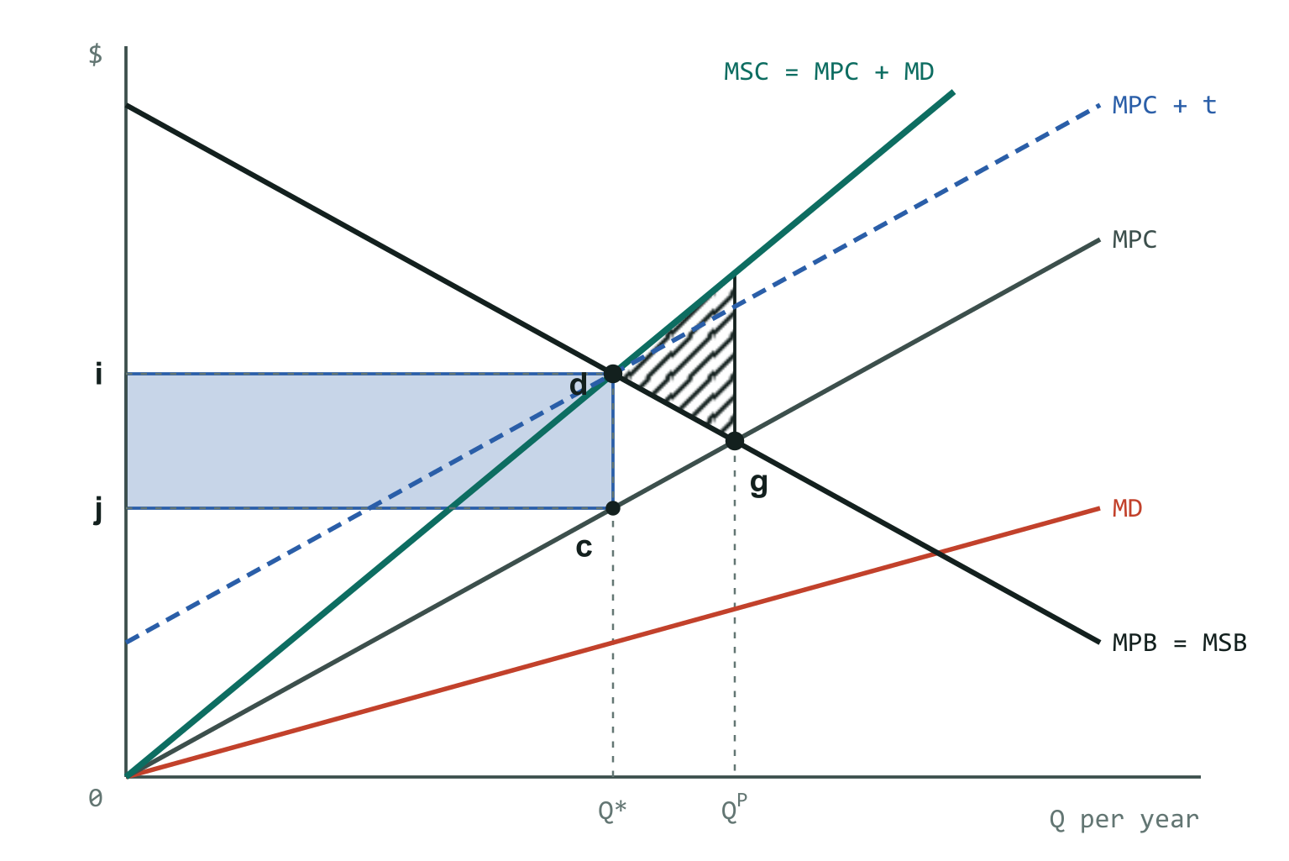
The tax shifts MPC up by cd so it passes through d. Blue = tax revenue; hatched dhg = efficiency gain.
If bargaining isn't possible, the government can put a price on the pollution. Set a tax per unit equal to marginal damage at the efficient output:
t = MD(Q*) = distance cd = distance ij on the axis
Pharma's cost of each unit becomes MPC + t: the MPC line shifts up by cd and now passes through d. Pharma maximises profit where MPB = MPC + t, which only happens at Q*. The tax makes Q* privately optimal.
government revenue: t · Q* blue rectangle, height cd, width Q*
Pharma's lost profit: t · Q* + dcg pays the tax and produces less
growers' damage falls: cdhg
net efficiency gain: cdhg − dcg = dhg
The tax equals MD at Q*, not MD at Q^{P}. And the revenue does not have to go to the growers — the book warns that compensating them can itself distort behaviour.
In numbers: t = MD(4) = 2. Pharma solves 10 − Q = Q + 2 → Q = 4. Revenue 2 × 4 = 8; Pharma loses 8 + 1 = 9; growers gain 2.25; society gains 1.25.

Step 11 — Pigouvian subsidy slides 29–30
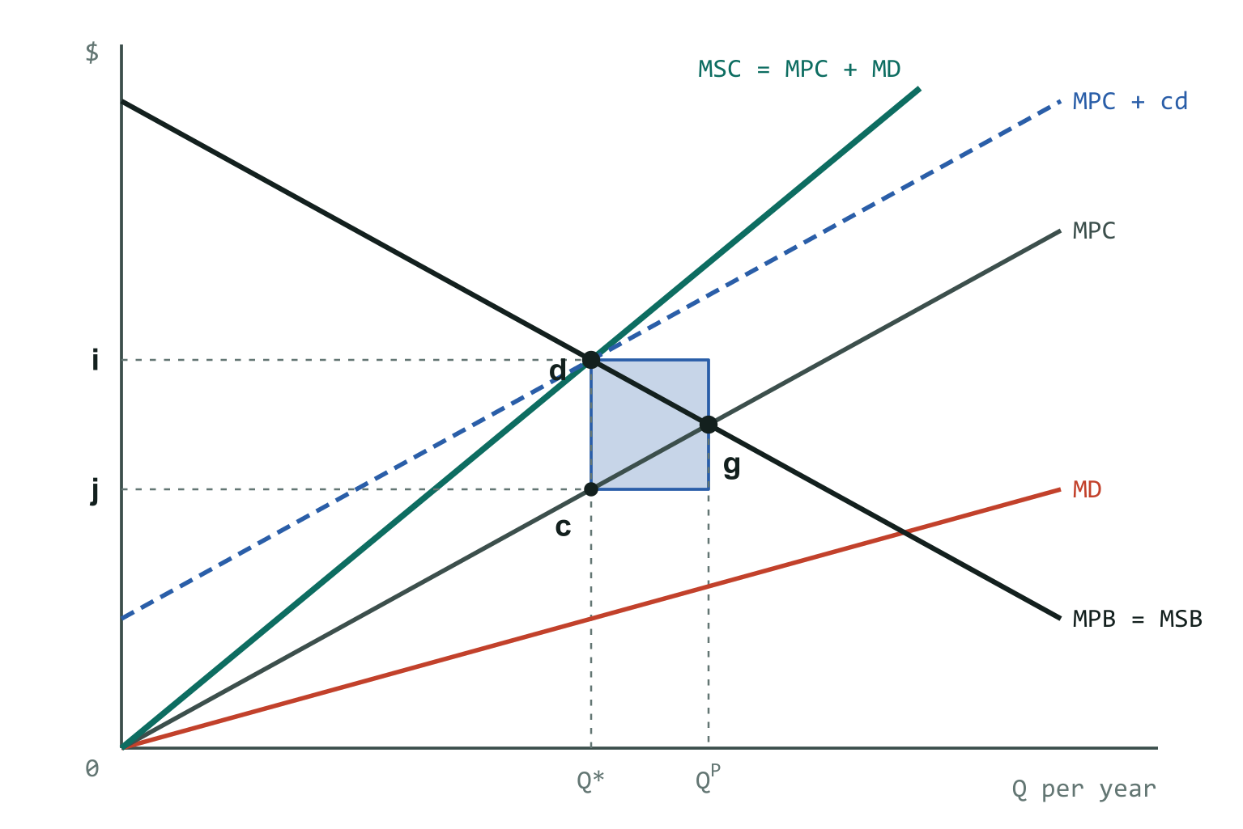
Blue = subsidy bill, cd for each unit cut between Q* and Q^{P}.
The mirror image: pay Pharma cd for every unit it produces below Q^{P}.
Producing one more unit now costs Pharma its MPC plus the subsidy it gives up by not cutting that unit — cd. So its effective marginal cost is again MPC + cd, and it chooses Q*, exactly as under the tax.
subsidy bill = cd × (Q^{P} − Q*)
Tax and subsidy give the same output. The difference is distribution (slide 30): under the tax Pharma pays the government, under the subsidy the government pays Pharma. Both require the government to know MD, which in practice is hard — plenty of room for government failure.
In numbers: 2 × (5 − 4) = 2 paid to Pharma.

Summary: every point and area
Point | Where it is
g | MPB meets MPC — the market outcome, at Q^{P}
d | MPB meets MSC — the efficient outcome, at Q*
c | on MPC, directly below d (so cd = MD at Q*)
h | on MSC, directly above g (so hg = MD at Q^{P})
a, e | on the Q axis at Q* and Q^{P}
b, f | on the MD curve at Q* and Q^{P}
i, j | on the $ axis at the heights of d and c — so ij = cd, the tax rate

Area | Measures | Formula | Example
dcg (= cdg) | Pharma's lost profit going Q^{P} → Q*; minimum Coase payment when Pharma owns the river | ∫ (MPB − MPC) | 1
abfe | Growers' reduction in damage going Q^{P} → Q*; maximum Coase payment when Pharma owns the river | ∫ MD | 2.25
cdhg | The same as abfe, redrawn between MPC and MSC | ∫ (MSC − MPC) | 2.25
dhg | Deadweight loss of the market outcome; efficiency gain from the tax, the subsidy or bargaining | ∫ (MSC − MSB) | 1.25
t · Q* | Pigouvian tax revenue | cd × Q* | 8
cd × (Q^{P} − Q*) | Cost of the Pigouvian subsidy | cd × (Q^{P} − Q*) | 2
All integrals run from Q* to Q^{P}.
Slides 12 and 31 are blank "exercise" slides in the file, presumably worked on the board, so they are not covered here.

